**Project Design Phase-II**

### Determine The Requirements

|  |  |
| --- | --- |
| **Date** | **02 November 2023** |
| **Github name** | **https://github.com/Nareshkumar2001/Naan-Mudhalvan-Salesforce** |
| **Project Name** | A CRM Application For Managing Loan App and Fraudulent Prevention. |

Creating a CRM (Customer Relationship Management) application for managing loan applications and preventing fraud requires a comprehensive understanding of the specific needs and objectives of your organization. To determine the requirements for such an application, you should follow a structured process. Here's a step-by-step guide:

**Define Objectives and Scope:**

Clearly define the objectives of your CRM application, such as improving customer service, streamlining loan application processes, and preventing fraud.

Determine the scope of the application, including the types of loans you'll handle and the fraud prevention mechanisms you want to incorporate.

**Identify Stakeholders:**

Identify all stakeholders, such as loan officers, underwriters, fraud detection teams, and customers. Gather their input to understand their needs and expectations.

**Gather Requirements:**

Conduct interviews and surveys with stakeholders to gather detailed requirements. This can include features, data needs, and user workflows.

Consider regulatory and compliance requirements related to loans and fraud prevention.

**Functional Requirements:**

**Define the core features of the CRM application:**

* Loan application submission and tracking
* Customer information management
* Document management
* Fraud detection and prevention
* User roles and permissions
* Reporting and analytics
* Integration with external data sources and credit bureaus
* Communication tools (email, notifications, alerts)

**Non-functional Requirements:**

Consider non-functional requirements such as system performance, security, scalability, and availability.

**Data Requirements:**

Specify the types of data you need to store and manage, including customer profiles, loan application details, and historical data for fraud detection.

**User Experience (UX) Design:**

Work with UX designers to create a user-friendly interface that supports the application's functionality.

**Fraud Detection and Prevention:**

* Determine the fraud prevention mechanisms:
* Identity verification
* Document verification
* Behavior analysis
* Integration with fraud detection services
* Machine learning models for anomaly detection

**Compliance and Security:**

Ensure that the application complies with legal and regulatory requirements, such as GDPR, HIPAA, and financial industry regulations.

Implement robust security measures to protect sensitive customer data**.**

**Integration:**

Plan how the CRM application will integrate with other systems, such as credit bureaus, payment processors, and legacy systems.

**Testing and Quality Assurance:**

Develop a testing strategy to ensure that the application meets its requirements and functions correctly.

**Deployment and Training:**

Deploy the CRM application in a production environment and provide training to staff.

**Monitoring and Maintenance:**

Implement ongoing monitoring for fraud prevention and application performance.

Regularly update and maintain the application to address evolving threats and requirements.

**Feedback and Iteration:**

Continuously collect feedback from users and stakeholders to make improvements and updates to the CRM application.

**Documentation:**

Create comprehensive documentation for users and administrators to ensure smooth operation and troubleshooting.

**Support and Customer Service:**

Provide robust customer support to assist users and address any issues or questions.

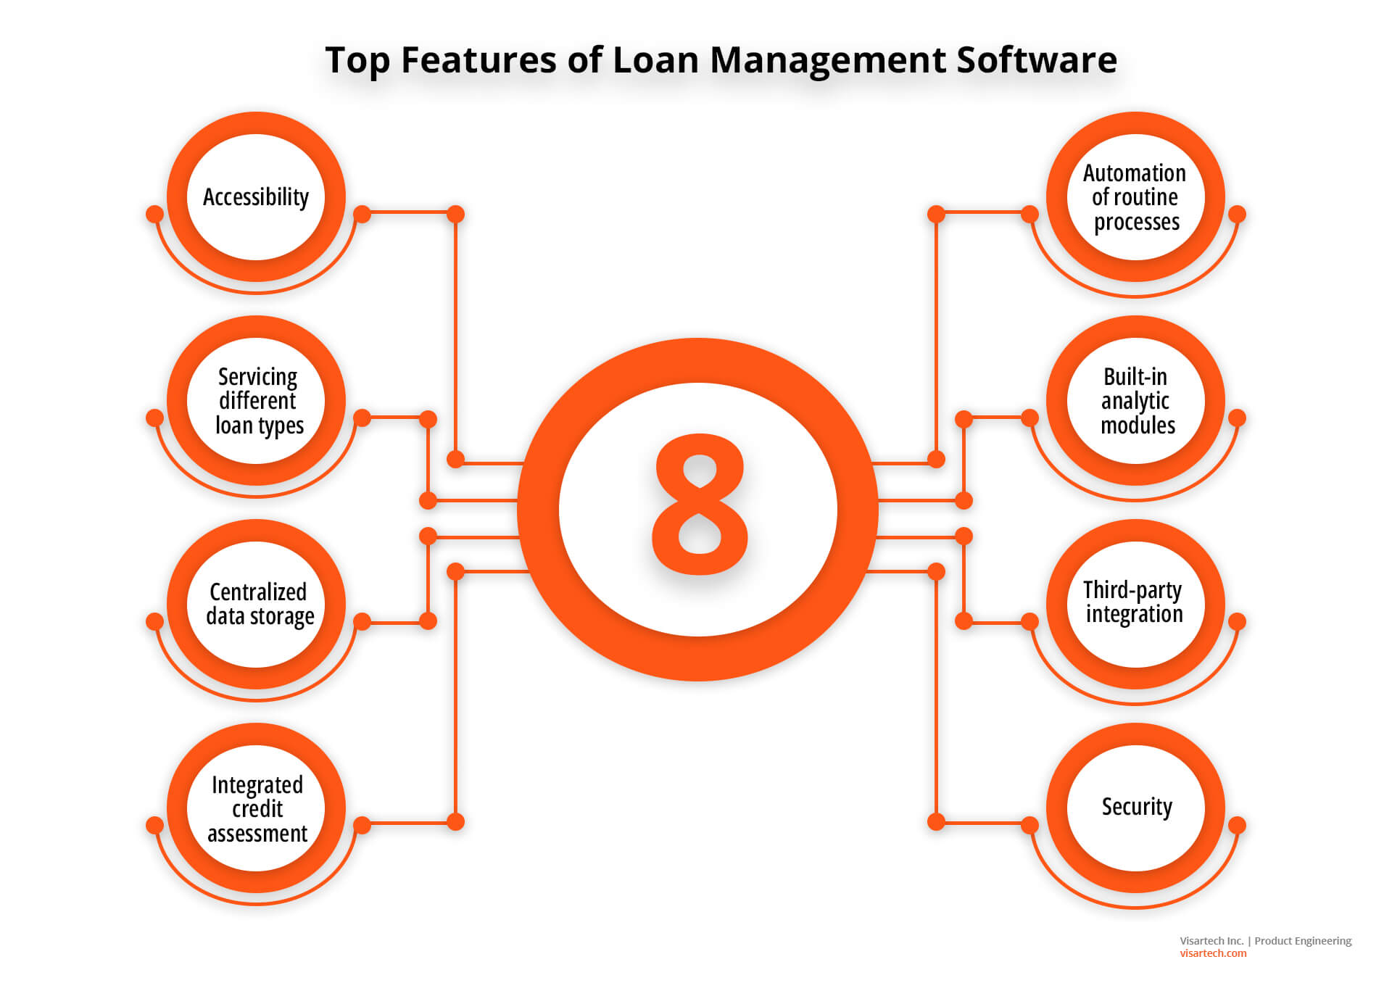

Building a CRM application for managing loans and preventing fraud is a complex and multifaceted project. Engaging with experienced software developers, data scientists, and security experts is essential to ensure the success of this project. Additionally, consider the use of existing CRM platforms and financial software solutions as a foundation, and customize them to meet your specific requirements if it aligns with your objectives.